1. **How to Bypass Object Repository (OR) in QTP**

Yes - we can do automation of any application bypassing the OR. I know you must be knowing how we can do it.  
  
Using descriptive programming we can easily bypass OR.  
  
Code below will make you understand how to bypass OR in QTP.  
  
                 Set objLinkDash = Description.Create  
                objLinkDash("micclass").Value = "Link"  
                objLinkDash("html tag").Value = "A"  
  
                Set lnkObj=constobjParent.childobjects(objLinkDash)  
  
                For i=0 to lnkObj.count-1  
                print lnkObj(i).getROProperty("innertext")   
                Next

1. **RepositoriesCollection Object in QTP**

 RepositoriesCollection Object is used to associate or disassociate shared object repositories to QTP at run time  
  
At the beginning of a run session, the RepositoriesCollection object contains the same set of object repository files as the Associated Repository Files tab of the Action Properties dialog box. The operations you perform on the RepositoriesCollection object affect only the run-time copy of the collection.  
  
You use the RepositoriesCollection object to associate or disassociate shared object repositories with an action during a run session.

**RepositoriesCollection Methods**  
      
  
Add   - Add .tsr file to current action in test  
  
Find  - Find the index position of .tsr file in collection  
  
MoveToPos  - Change the position of  repository  
  
Remove   - Remove repository from current action in test  
  
RemoveAll  - Remove all repositories from current action in test  
  
  
**RepositoriesCollection Properties**  
    
Count   - Get the total number of .tsr files associated to current action in test  
  
Item   - gets the path of the tsr file located in the specified index position.

 We can add any number of .tsr files to current action in test at run time.  
  
Example -   
  
RepPath = "c:\Mercury\my.tsr"  
  
RepositoriesCollection.RemoveAll()  
  
RepositoriesCollection.Add(RepPath)  
  
Pos = RepositoriesCollection.Find(RepPath)  
  
RepositoriesCollection.Remove(Pos)   
  
RepositoriesCollection.Add(RepPath)    ' add tsr filr  
  
Window("Microso").WinObject("my").Click   
  
Pos = RepositoriesCollection.Find(RepPath)

1. **Difference between local and shared OR**

Local OR is used by only one action in Test While Shared OR can be used by multiple actions and tests

Local OR can be edited without OR manager While shared OR can be edited by using only OR manager

We can not merge 2 local OR but we can merge 2 shared ORs using OR manager

We can not compare 2 local OR but we can compare 2 shared ORs using OR manager

We can associate/disassociate the shared OR to test at run time but Local OR is associated to test at anytime by default.

Extension of the shared OR is .tsr while Local OR is .mtr

When we export the Local OR, shared OR is created.

1. **How to Associate Object Repository to QTP Test**

Well - we can associate object repository to QTP Test either manually or by automation code.

Manually with Test Settings - In this method you have to go to Resources->Associate repositories. Here you can give the path of tsr file that is Shared OR.

By Automation Code, You have to use repositories collection object as mentioned in below code.

Dim QTPAPP

Dim qtObjRes

Set QTPAPP= CreateObject("QuickTest.Application")

QTPAPP.Launch

QTPAPP.Visible = True

QTPAPP.Open "C:\Test\Testabc", False, False

 Set qtObjRes = QTPAPP.Test.Actions ("Login").ObjectRepositories

qtObjRes.Add "C:\OR\myRes.tsr", 1

1. **When to use descriptive Programming in QTP**

Descriptive programming in QTP is used in below scenarios.

Whenever the objects in the applications change quite often.

When it is not feasible to store the objects in OR. For example all links on the page

When same object exists in the different pages/windows of the application.

There are 2 types of description programming.

Static Descriptive programming

Dynamic Descriptive programming

***Static Descriptive programming Example -***  
  
 Browser("index:=0").page("title:=Google").webedit("name:=q").set "xyz"  
  
***Dynamic Descriptive programming Example -***'Find all edit boxes on google page using descriptive programming  
Set descriptionObject = Description.Create()  
descriptionObject("micclass").value = "webedit"  
descriptionObject("outerhtml").value = ".*input.*"  
descriptionObject("outerhtml").regularexpression = true  
  
set col = Browser("index:=0").page("title:=Google").childobjects(descriptionObject)  
  
print "Total edit boxes on the page"  & col.count  
  
For i=0 to col.count-1  
 print col(i).getROProperty("outerhtml")  
   
Next

1. **Test Settings in QTP**

Test settings is very important part of the QTP test. You can open the test settings from the file sub menu.  
You will find below sections in test settings window.  
  
**1. Properties Settings:**  
In properties section you will find the location of the test and add-ins associated with the test.

[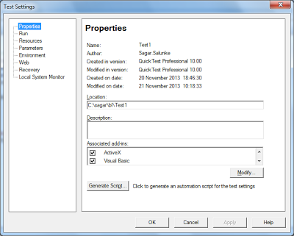](http://3.bp.blogspot.com/-H9fe5dZ15JY/UpLnbq0rWRI/AAAAAAAAA9Y/e6xKNMRrY5U/s1600/test-properties.png)

**2. Run Settings:**  
In run section you will find below settings.

Data table iterations

When error occurs - what to do

Object Synchronization timeout

[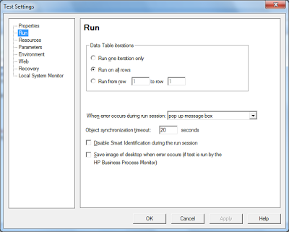](http://3.bp.blogspot.com/-bYHgl1mJNDo/UpLne6dpcDI/AAAAAAAAA-A/U-VAVWpZtd4/s1600/test-settings-run.png)

**3. Resources Settings:**  
In resources section you will be able to see/edit the associated function libraries of the test.

[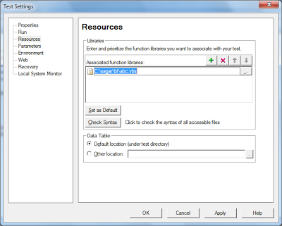](http://4.bp.blogspot.com/-TvxBiNyLXvY/UpLnd75Xm7I/AAAAAAAAA9w/DgE82GsIfMQ/s1600/test-settings-resources.png)

**4. Parameters Settings:**  
In parameters section you will specify the input and ouptu parameters.  
  
You can access the parameters using script as mentioned below.

Set qtApp = CreateObject("QuickTest.Application") ' Create the Application object  
Set pDefColl = qtApp.Test.ParameterDefinitions  
Set rtParams = pDefColl.GetParameters() ' Retrieve the Parameters collection defined for the test.  
Set rtParam = rtParams.Item("sagar") ' Retrieve a specific parameter.  
print rtParam.value

[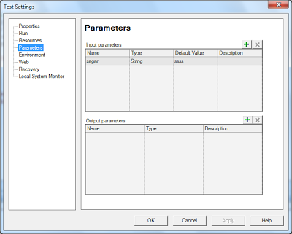](http://3.bp.blogspot.com/-v-p10x3pHOo/UpLndvauBSI/AAAAAAAAA9s/MtxZC1sfGrg/s1600/test-settings-parameters.png)

**5. Environment Settings:**  
In Environment section you can view built - in and user defined global variables. You can also create new user defined variables here.

[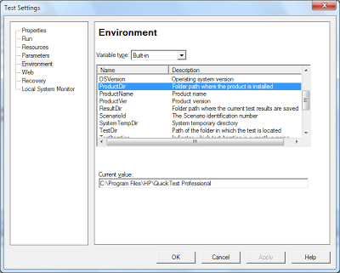](http://4.bp.blogspot.com/-xzKZ8boZqlw/UpLnbgX_M7I/AAAAAAAAA9U/XUxmS1AHqw4/s1600/test-settings-environment.png)

**6. Web Settings:**  
In web section you can specify the browser navigation timeout.

[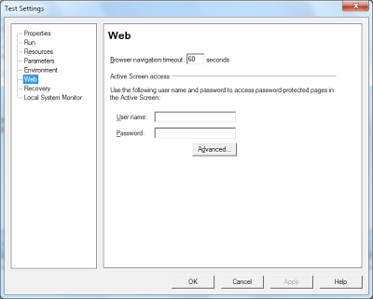](http://2.bp.blogspot.com/-OmhD384Hn0A/UpLnfBMb3lI/AAAAAAAAA-E/YvI0Bg7r4uM/s1600/test-settings-web.png)

**7. Recovery Settings:**  
In recovery section you will be able to add and activate/deactivate  new recovery scenarios to the test.  
You can also view the properties of the scenarios.

[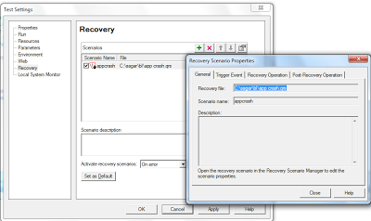](http://4.bp.blogspot.com/-ds9wsF_Z2lY/UpLndRUKJiI/AAAAAAAAA9o/5sfugq7LAss/s1600/test-settings-recovery-scenario.png)

**8. Local System Monitor Settings:**  
In this section you can monitor the various properties of the system like memory usage, cpu usage by given application during test execution.

[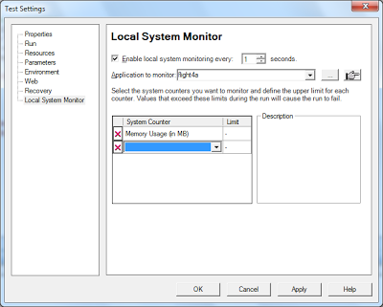](http://1.bp.blogspot.com/-sNUMna48Zp8/UpLnbmGNngI/AAAAAAAAA9Q/ywx1Ts8fKXQ/s1600/test-settings-local-system-monitor.png)

1. **Recovery Scenario in QTP with Example**

Recovery scenarios are used to handle the unexpected events that might occur while test execution is going on by QTP.

Please find below the steps that have to be followed to create the recovery scenario in QTP.

First of all You have to open the recovery scenario manager.  In resources menu you will find  recovery scenario manager option. Click on that and you will get to see below window.

**Step1: Open Recovery  Scenario Manager.**

Using recovery scenario manager you can create new recovery scenarios and store it in a file with .qrs extension.

One qrs file may contain multiple recovery scenarios.

To create new recovery scenario, click on the button circled with red color. It will open recovery scenario wizard.

[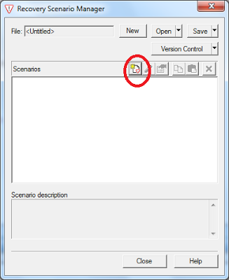](http://1.bp.blogspot.com/-uPatlWGUDWU/UpLgOb6bU_I/AAAAAAAAA8g/MFzK6GkZwac/s1600/recovery-scenario-manager.png)

**Step 2: Open Recovery  Scenario Wizard.**

Recovery scenario wizard shows the steps involved in creating the recovery scenario. Click on Next

[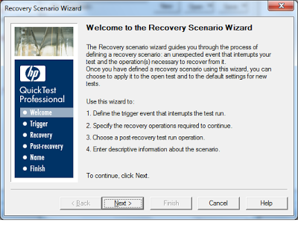](http://4.bp.blogspot.com/-aeUGYRSiutE/UpLgOPedHrI/AAAAAAAAA8k/4SpcsZQmbAY/s1600/Recovery+scenario+wizard+-+welcome+page.png)

**Step 3: Select Trigger Event.**

There are 4 types of the trigger events.

Pop up window

Object State

Test Run Error

Application Crash

[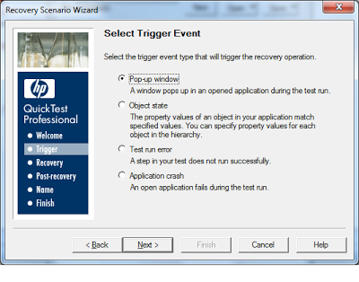](http://1.bp.blogspot.com/-TDOqMIo67Us/UpLgKG5RphI/AAAAAAAAA7w/m-41Jq9xOMk/s1600/Recovery+scenario+wizard+-+Define+trigger+event.png)

**Step 4: Specify the trigger Details.**

In this step you have to specify more details about the trigger. For example if you selected pop up window in trigger event above, you will have to provide the title or text of the pop up as shown below.

**[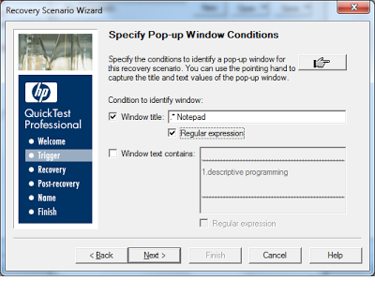](http://2.bp.blogspot.com/-hLTc9rZvbJY/UpLgKCjAfRI/AAAAAAAAA7s/NJQDW0t1NzA/s1600/Recovery+scenario+wizard+-+describe+pop+up+window.png)**

**Step 5: Recovery Operation.**

After specifying the trigger event, you have to provide the recovery operation. There are 4 types of the recovery operations.

Keyboard or mouse operation

Close application process

Function Call

Restart Microsoft Windows

[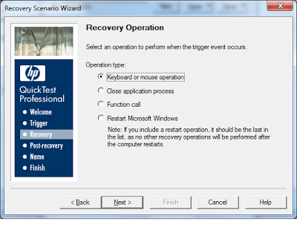](http://2.bp.blogspot.com/-fNLeHTSXmtg/UpLgK_dBJnI/AAAAAAAAA78/v1_8YrDT290/s1600/Recovery+scenario+wizard+-+define+recovery+operation.png)

[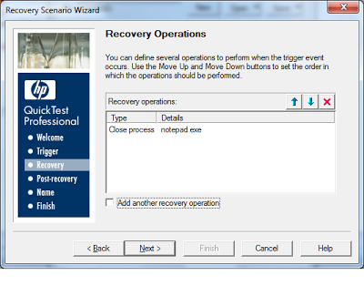](http://3.bp.blogspot.com/-BF6qQ0DljDM/UpLgL-_U_1I/AAAAAAAAA8E/0DBakKrMdzk/s1600/Recovery+scenario+wizard+-+exit+recovery+operation.png)

**Step 6: Post Recovery  Operation.**

In Post Recovery You can tell what step should be executed after recovery is done by QTP.

[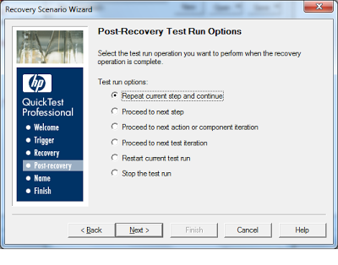](http://3.bp.blogspot.com/-8fFPAVnomfY/UpLgOLH3qrI/AAAAAAAAA8c/je1JOkIcyrE/s1600/Recovery+scenario+wizard+-+post+recovery+operation.png)

**Step 7: Name the Recovery  Scenario.**

You have to give the name to recovery scenario in this step

[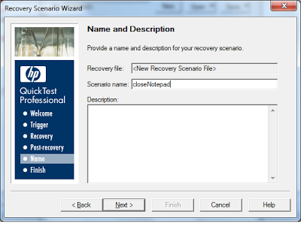](http://1.bp.blogspot.com/-IPoiRseuGtU/UpLgNPzCoXI/AAAAAAAAA8U/aqu1qdEo3ek/s1600/Recovery+scenario+wizard+-+give+a+scenario+name.png)

**Step 8: Finishing the recovery scenario.**

This is last step. You can add this scenario to current test in this step.

[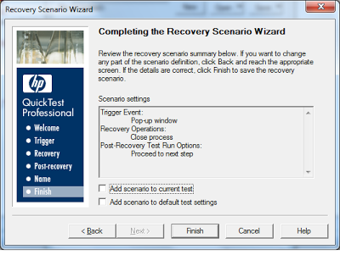](http://4.bp.blogspot.com/-ZApbIa4TBDM/UpLgMnKpq2I/AAAAAAAAA8M/8FGSTCIva6M/s1600/Recovery+scenario+wizard+-+finish.png)

 Once you click finish recovery scenario manager window will be shown where you can save the qrs file.  
  
Please note that to activate recovery scenario, you have to go to test settings.

1. **Datatable object in QTP**

Datatable is nothing but run-time Data Table in QTP. Datatable is used to store test data in QTP.  
In QTP Every test has one datatable in it. In Datatable there is one global sheet and one local sheet for each action in Test.   
  
Please note that changes made in run time datatable will last until you execution is going on. To save the run time data table you must use export method.

**Methods of Run time datatable in QTP:-**

* AddSheet Method - Used to add new sheet to datatable
* DeleteSheet Method - Used to Delete existing sheet from datatable in QTP
* Export Method - Used to export all sheets from datatable to new excel workbook in QTP
* ExportSheet Method - Used to export existing sheet from datatable to new excel sheet in QTP
* GetCurrentRow Method - Gets the row number of current active row from datatable
* GetRowCount Method - gets the total number of rows from current active sheet from datatable
* GetSheet Method - Gets the reference to existing sheet in datatable.
* GetSheetCount Method - Gets the count of total number of sheets from datatable in QTP
* Import Method - loads the all sheets from external workbook to runtime datatable in QTP
* ImportSheet Method - loads the particular sheet from external workbook to runtime datatable in QTP
* SetCurrentRow Method - Sets the particular row active in current active sheet.
* SetNextRow Method - Used to move to next row in current active sheet in datatble in QTP
* SetPrevRow Method - Used to move to previous row in current active sheet in datatble in QTP

**Properties of Run time datatable in QTP :-**

* GlobalSheet Property - Gets the reference of global sheet in datatable in QTP
* LocalSheet Property - Gets the reference of particular local sheet from datatable in QTP
* RawValue Property - The raw value is the actual string written in a cell before the cell has been computed, such as the actual text from a formula.
* Value Property - Gets the value from cell - given sheet and active row and column name or index

1. **What are the Utility objects in QTP?**

QTP provides some of the utility objects as mentioned below. Main objective of the utility objects is that Utility objects help us in performing lot of tasks in QTP easily.  
  
**List of the frequently used utility objects with their importance is given below.**

* [Crypt Object](http://qtp-interview-questions.blogspot.com/2013/03/crypt-object-in-qtp.html)                       --> Encrypts/Decrypts the string
* [DataTable Object](http://qtp-interview-questions.blogspot.com/2013/03/datatable-object-in-qtp.html)                --> All datatable operations
* [Description Object](http://qtp-interview-questions.blogspot.com/2013/03/description-object-in-qtp.html)               --> We can do dynamic descriptive programming
* [DotNetFactory Object](http://qtp-interview-questions.blogspot.com/2013/03/dotnetfactory-object-in-qtp.html)         --> Allows access to Static Dot Net Classes
* [Environment Object](http://qtp-interview-questions.blogspot.com/2013/03/types-of-environment-variables-in-qtp.html)             -->  We can create and access environment values
* [Extern Object](http://qtp-interview-questions.blogspot.com/2013/03/externdeclare-in-qtp.html)                      --> Access dll
* [MercuryTimer Object](http://qtp-interview-questions.blogspot.com/2013/03/mercury-timer-object-in-qtp.html)           --> Timer related operations
* [RandomNumber Object](http://qtp-interview-questions.blogspot.com/2013/03/how-to-get-random-number-in-qtp.html)        --> Create random number
* [Recovery Object](http://qtp-interview-questions.blogspot.com/2013/03/use-of-recovery-scenario-manager-in-qtp.html)                   --> Recovery Scenario handling
* [Reporter Object](http://qtp-interview-questions.blogspot.com/2013/03/reporter-object-in-qtp.html)                    --> Used to report the test results
* [RepositoriesCollection Object](http://qtp-interview-questions.blogspot.com/2013/03/repositoriescollection-object-in-qtp.html)--> Dynamic Repository
* Repository Object                  --> Access test object repository at runtime.
* TextUtil Object                      --> TextUtil is used to process text
* XMLUtil Object                    --> xmlUtil is used to process xml data.

1. **How to take a screenshot in QTP?**

In QTP, when we execute the test cases, test cases may fail due to valid / invalid defects. They may also fail due to script issues or any other issues like network failure.  
  
After the test execution ends, We only have the html reports or QTP results with us which does not give clear picture about the status of application. To solve this problem we can take the snapshot of the application when any test step fails.  
  
Example - Below code will take the screen shot. You can insert this code anywhere you want to take the screen shot.  
  
Window("xyz").CaptureBitmap "c:\screenshots\abc.png",True  
'In above code we are storing the png image file to c drive location. Second parameter tells whether to overwrite existing file.  
  
Thus you can use capturebitmap method of any object to take the screen shot.

1. **How to add standard checkpoints in QTP**

Checkpoints are used to verify the property values with expected ones. If they match checkpoints pass else they fail.  
  
You can add standard checkpoint by right clicking the statement and then selecting the insert standard checkpoint menu.  
  
Sample checkpoint window is shown here..

[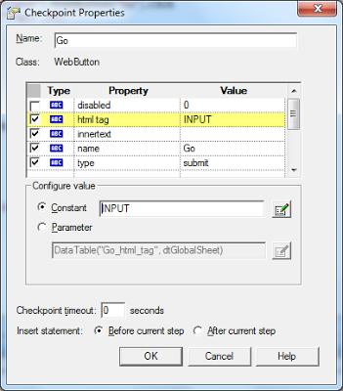](http://4.bp.blogspot.com/-d34PvPLS5jw/UpL5BmTz37I/AAAAAAAAA_E/k4jyfs9Qqww/s1600/checkpoint+window.png)

Browser("Google").Page("Google").WebEdit("q").Set "salunke"  
  
Browser("Google").Page("Google").WebEdit("q").Check CheckPoint("q_2")  
  
Browser("Google").Page("Google").WebEdit("q").Output CheckPoint("q")  
  
Browser("Google").Page("Google").WebButton("Google Search").Clic   
  
Results window showing the checkpoint status

[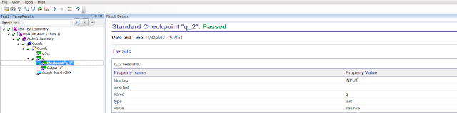](http://3.bp.blogspot.com/-mgNBgucq4yM/UpL4ZFNac-I/AAAAAAAAA-8/SYbQWjCNabk/s1600/CHECKPOINT.png)

1. **How to create output value in QTP?**

Output value is used to store the data generated by application while execution is going on for later use.  
For example - Suppose after you place the order, order id is generated. So you can store this order id in output value so that you can use this value for later use ..say to fax the order  
  
To add the output value you have right click on the statement after which you want to add output value.  
Once you right click you will find the output value properties window like the one below.

[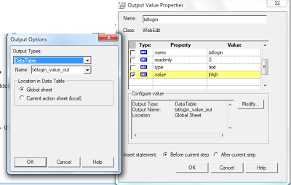](http://1.bp.blogspot.com/-bvRonnlTmXs/UpL2_b0-GZI/AAAAAAAAA-o/attxJULcK78/s1600/output.png)

You can check the property values that you want to store in the output value. You can also specify where you want to store the values (datatable or environment)

Browser("Google").Page("Google").WebEdit("q").Set "salunke"  
  
Browser("Google").Page("Google").WebEdit("q").Output CheckPoint("q")  
  
Browser("Google").Page("Google").WebButton("Google Search").Click  
  
  
[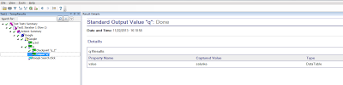](http://3.bp.blogspot.com/-7G3zgmfg4fg/UpL3AXabgfI/AAAAAAAAA-w/be4-SWHyfwg/s1600/OUTPUT+VALUE.png)  
  
When You execute the script, in results you can find the output values.

1. **What is the use of start transaction in QTP?**

In QTP you will find one option called start/end transaction.  
  
Transactions in qtp  are used to calculate the time required to perform the given operation  
You can start the transaction using below syntax  
  
Example on Transactions in QTP  
  
Services.StartTransaction "transfer"  
a = 2  
b = a+2  
'do some more opertions  
  
Services.EndTransaction "transfer"  
  
Once the transaction is complete, total time required to execute the transaction is logged in the QTP results automatically.

[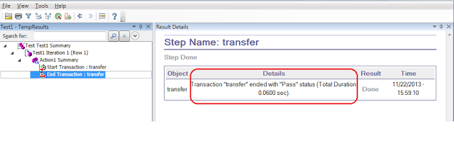](http://1.bp.blogspot.com/-rMxkLi48Ebw/UpLxXlJRmeI/AAAAAAAAA-Y/uM1ij4swnMU/s1600/transactions.png)

1. How to see associated library files in QTP using script?

We can iterate all library files attached to test in QTP using below code.  
  
Set qtpApp = CreateObject("QuickTest.Application")  
qtpApp.Launch  
qtpApp.Visible = True  
  
  
Set qtLibraries = qtpApp.Test.Settings.Resources.Libraries  
' Get the libraries collection object  
  
For each l in qtLibraries  
                'here we are printing the names of all library files associated with this test.  
                 print l  
Next  
  
We can also associate the library file to test at runtime using below code  
   qtLibraries.Add "C:\book.vbs"  
' Add the library file viz. book.vbs to the collection.  
  
We can also check if given file is associated with the test using below code.  
  
If qtLibraries.Find("C:\myfile.vbs") = -1 Then  
    print "library file not found"  
 else  
    print "library file found"  
End If  
  
'Save the test  
qtpApp.Test.Save  
qtpApp.Quit  
  
 ' Quit QuickTest  
  
Set qtLibraries = Nothing  
Set qtpApp = Nothing

This is how we can work with QTP libraries.

1. **How to open any website(URL) in browser (IE,chrome, firefox) in QTP?**

You can use below code to open an url in QTP.  
  
url = "www.google.co.in"  
  
SystemUtil.Run "iexplore.exe" , url ,,,3  
SystemUtil.Run "firefox.exe" , url ,,,3  
SystemUtil.Run "chrome.exe" , url ,,,3  
Above code will open url in all browsers.  
In plain vbscript you can use below code to open a url.  
  
Set o = createobject("wscript.shell")  
o.Run "chrome.exe www.makaan.com"  
o.Run "firefox.exe www.makaan.com"  
Set o = nothing

A

1. **How to load ini(XML) file in QTP?**

Ini files are used to store global data required for testing.  
  
Typical ini file looks like this.

[Environment]

                URL=http://xyz.com

                UserId=abc

                Password=pass

 [Environment]

Example -

To load above ini file in QTP script, you have to use below lines of code

Environment.LoadFromFile “c:\Environment_Variable\Env.ini"

Print  Environment.Value("URL")

This is how you can read values from ini file in QTP.

1. **Folder Structure and File extentions in QTP?**

Please note that below article is written for QTP 10.  
  
When we save any test in QTP 10 below folders are created.   
  
For example - If we save the test as book in c drive then one folder will be created like c:\book. Under Book folder there will be below folders.  
  
Action 0  
Action 1  ' If we have one action in Test  
Action 2  ' If we have two actions in Test and so on.....

**Below mentioned files are also created under main test (book) folder.**

default.cfg                       - Text File - Web and network configuration

default.usp                       - Text File - Action Iteration Settings

default.xls                        - Datatable of the test

lock.lck

parameters.mtr                  - Binary File -

book.usr   (testname file)   - Text File

test.tsp                              - Binary file -  Test Settings

Under Each Action there will be one folder   
  
**• Snapshots**  
Under Each Action there will be below files.

objectrepository.bdb        - Local Object Repository

resource.mtr                     -

script.mts                         - Actual Code of action - Text File

analogtracklist.dat             -

**Other Files and thier Extentions in QTP.**

.vbs  - VBS library File

.txt    - Text Library File

.qfl    - Quick test function library file

.qrs   - Quicktest Recovery Scenario File

.tsr    - Shared Object Repository file

1. **Difference between dictionary and array in QTP**

Here is the difference between Array and dictionary in QTP.  
Below comparison illustrates when we should use array and dictionary.

|  |  |  |
| --- | --- | --- |
|  | Array | Dictionary |
| 1 | We can have dynamic array | We do not have concept called dynamic Dictionary. |
| 2 | Before use of array we must set the size of array | We do not need to set the size of dictionary. |
| 3 | Before adding extra element into dynamic array, We have to use redim  statement | We do not need to write any statement to add extra element. We just use add method. |
| 4 | We do not have any method to release the memory if particular element is not required | We can remove the element that is not required any longer. |

Dictionary object has many in built functions that help us add, remove, access the elements by unique key. That is why we must use dictionary over array.  
  
Please note that array does not have any methods to add/remove the elements.

1. **Filesystemobject methods in QTP?**

Filesystemobject is used to access the computer's file system in QTP. You can read, edit, delete files using this object. You can also create/ delete folders using this object in QTP.  
  
***Most important methods of Filesystemobject***  
  
CopyFile Method ----------->copies file from one location to other with option to overwrite existing file  
CopyFolder Method---------->copies folder and its contents from one location to other with option to overwrite existing folder  
CreateFolder Method-------->creates a new folder. If the folder already exists, error occurs. So before creating a folder, check for its existance  
CreateTextFile Method------>creates a new file and returns the textstream object with option to overwrite and format mode (Ascii or unicode)  
DeleteFile Method---------->deletes the specified file. Error occurs if the given file does not exist  
DeleteFolder Method-------->deletes the specified folder. Error occurs if the given folder does not exist  
DriveExists Method--------->returns true if the given drive exists in the system else returns false  
FileExists Method---------->returns true if the given file exists in the system else returns false  
FolderExists Method-------->returns true if the given folder exists in the system else returns false  
GetDrive Method------------>returns drive object for the given drive  
GetFile Method------------->returns file object for the given file  
GetFolder Method----------->returns folder object for the given folder  
MoveFile Method------------>moves file from one location to another  
MoveFolder Method---------->moves folder and it's contents from one location to another  
OpenTextFile Method-------->opens the text file and returns the textstream object with option of iomode, create new file and format mode(ascii/unicode)  
  
GetDriveName Method-------->gets the drive name for the given path  
GetFileName Method--------->gets the file name (last component ) for the given path  
GetExtensionName Method---->gets the extension for the given path like txt, mp3 etc  
GetAbsolutePathName Method->gets the complete path for the given relative/absolute path  
GetBaseName Method--------->gets the name of file (last component) excluding extension  
GetParentFolderName Method->Gets the name of parent folder  
  
  
Filesystemobject has only one property   
Drives Property------------>returns the collection of the drives objects in the system

**Examples on filesystem object**  
  
   Set fso = CreateObject("Scripting.FileSystemObject")  
  
   print fso.GetdriveName("c:\sagar\bl\metachara.txt")  
   'output -  c:  
   print fso.GetAbsolutePathName("c:\sagar\bl\metachara.txt")  
   'output - C:\sagar\bl\metachara.txt  
   print fso.GetExtensionName("c:\sagar\bl\metachara.txt")  
   'output - txt  
   print fso.GetBaseName("c:\sagar\bl\metachara.txt")  
   'output - metachara  
   print fso.GetFileName("c:\sagar\bl")  
   'output - bl

1. **How to access the excel as a database using adodb.connection in QTP?**

We can work with excel in 3 ways in QTP as mentioned below.

Using Excel.Application

Using Adodb.Connection

Using DataTable

To know how we can use Excel.Application to read or write the excel files, you can refer these [links](http://qtp-interview-questions.blogspot.com/2013/03/how-to-read-value-from-excel-cell-in-qtp.html).  
  
To know how to use datatable to load excel into it, use these [links](http://qtp-interview-questions.blogspot.com/2013/10/how-to-import-excel-sheet-to-datatable.html).  
  
In this article we will see how we can read or write excel files using Adodb.Connection object.  
Excel workbook is considered as a database. Each sheet in the excel workbook is considered as a table.  
First row in the sheet is considered as column header and all other rows are considered to be records.  
  
***Here is the sample code to connect to excel database.***  
  
Set excelConnection = createobject("Adodb.Connection")  
excelConnection.open "Data Source=c:\abc.xlsx;Provider=Microsoft.Jet.OLEDB.4.0"  
Set rs = excelConnection.execute "Select * from [sheet1$]"  
For i=0 to rs.recordCount-1  
For j=0 to rs.fields.count-1  
print rs.fields(j).name & rs.fields(j).value  
Next  
Next

1. **How to Use HTML DOM in QTP?**

Well - If you are testing a web application then you will know the limitations of QTP as far as identification of objects is concerned.  
  
Many web objects have same properties. So QTP tries to identify the objects using Index - Ordinal Identifier.  
  
The disadvantage of using index is that It makes the script weak. What I mean here is that If developer adds new objects of similar types, Index of the existing objects also change. So QTP fails to identify the object due to changed index.

**So How you can use HTML DOM to handle such scenarios.**

Using html DOM you extract all kind of information from page as you can access source code of the page in the form of HTML.

HTML DOM has many method and properties associated with it like getElementById, nextsibling etc.

To access these methods you must create the DOM object first.

**Syntax to create a DOM object is -**

Set domObject = Browser ("myb").Page ("myp").object

Above statement will create the DOM object for the page called myp.

Now you can access the methods of the DOM object

Now let us use the dom object we have created above to get more information of the page currently displayed in the application.

Print domObject.getElementById("myid").innerText   ' Prints the text inside the Element - myid

Print domObject.getElementById("myid").innerHTML ' Prints the inner HTML of Element - myid

**How to access the parent object of given DOM Object**

You can also find the parentobject, nextsibling, previoussibling of the given dom object using built in properties as mentioned below.  
  
Set parentObj = domObject.getElementById("myid").parentNode  ' gets the parent object of myid  
Set nextsiblingObj = domObject.getElementById("myid").nextsibling 'gets the next sibling object of myid  
Set previoussiblingObj = domObject.getElementById("myid").previoussibling

Ok ..Now you are able to create DOM object...What Next?

Once you have created the DOM Object, you can access the text associated with that object. After getting the text you can process that as per your testing requirement.  
  
Print domObject.getElementById("myid").innerText         ' Prints the text inside the Element - myid  
Print domObject.getElementById("myid").innerHTML     ' Prints the inner HTML of Element - myid  
  
In above examples, I have used only getElementById method. But there are lot of other methods that you can use. For complete list of methods you can visit <http://www.w3schools.com/jsref/dom_obj_node.asp>  
  
**Some of the example of html dom in QTP are given below.**  
  
**How to get the collection of all TD (table data cells) elements of the table using HTML DOM in QTP?**  
Set tdtags =Browser(“abc”).Page(“mypage”).WebTable("mytable").Object.getElementsByTagName("TD")  
  
**How to get the collection of all TH (table header cells) elements of the table using HTML DOM in QTP?**  
set thtags = Browser(“abc”).Page(“mypage”).WebTable("mytable").Object.getElementsByTagName("TH")  
  
**How to get the value of attribute of any element using HTML DOM in QTP?**  
Set myobj = Browser(“abc”).Page(“mypage”).WebTable("mytable").Object  
Print myobj.getAttribute("class") 'This will print the value of class attribute of myobj - table   
  
**How to get the collection of all table rows using HTML DOM in QTP?**Set tableObj =Browser(“abc”).Page(“mypage”).WebTable("mytable").Object  
Set trtags = tableObj.getElementsByTagName("tr")  
  
**How to find the total number of rows in table Using HTML DOM in QTP?**  
print trtags.length

**How to get the value inside table cell Using HTML DOM in QTP?**

Set tdtags =Browser(“abc”).Page(“mypage”).WebTable("mytable").Object.getElementsByTagName("TD")  
Print tdtags(0).innerText 'print the text displayed inside first td tag in table

1. **Types of Automation Frameworks in QTP?**

Automation framework is designed to ease the process of test automation using QTP. Automation framework helps from scalability point of view. It is very easy to automate the test cases using automation framework rather than ad hoc approach.  
  
***There are mainly 3 types of Automation Frameworks in QTP***

Record and Play Back

Data Driven Framework

Keyword Driven Framework

Hybrid Framework

**Record and play back Framework:**   
In this Framework, User records the test steps in the application. This is very basic framework. Modular approach is not followed. Maintenance of the test scripts is time consuming and difficult.

**DATA Driven Framework:**   
In data driven framework, importance is given to test data than multiple functionality of application. We design data driven framework to work with applications where we want to test same flow with different test data. Test data is usually stored in the excel sheet. Test steps are stored in QTP script library.

**Keyword Driven Framework:**   
In Keyword Driven Framework, Importance is given to functions than Test Data. when we have to test multiple functionality we can go for keyword frameworks. Each keyword is mapped to function in QTP library and application. Test data and test steps are stored in the excel file.  
  
**Hybrid Framework -**  
This is the combination of keyword and data driven frameworks.  
  
After analyzing the application, you can decide what kind of framework best suits your needs and then you can design automation framework in QTP.

1. **Using UFT, how to send email from outlook?**

The given below code help in sending email from outlook −

Set Outlook = CreateObject ("Outlook.Application")

Dim Message 'As Outlook.MailItem

Set Message = Outlook.CreateItem (olMailItem)

With Message

.Subject = Subject

.HTMLBody = TextBody

.Recipients.Add (aTo)

Const olOriginator = 0

.Send

End With

1. **In UFT, how to get data from database?**

Follow the given below code to get data from database −

Set db = createobject (“ADODB.Connection”)

db.Open “Provider = Microsoft.Jet.OLEDB.4.0;Data Source=G:\guru99\vb6\admission_project.mdb;

Persist Security Info = False”

Set rst = createobject (“ADODB.Recordset”)

rst.Open “select*from Course”, db, 3

id = rst. RecordCount

For i = 0 to id-1

Print rst.field (0) & rst.fields (1) & rst.fields (2) & rst.fields (3)

rst.Movenext

Next